* **Write a C program to count distinct element in an array.  
  write algorithm and flowchart.**

#include <stdio.h>

void main()

{

int arr1[100], n,ctr=0;

int i, j, k;

printf("\n\nPrint all unique elements of an array:\n");

printf("------------------------------------------\n");

printf("Input the number of elements to be stored in the array :");

scanf("%d",&n);

printf("Input %d elements in the array :\n",n);

for(i=0;i<n;i++)

{

printf("element - %d : ",i);

scanf("%d",&arr1[i]);

}

printf("\nThe unique elements found in the array are : \n");

for(i=0; i<n; i++)

{

ctr=0;

for(j=0; j<i-1; j++)

{

if(arr1[i]==arr1[j])

{

ctr++;

}

}

for(k=i+1; k<n; k++)

{

if(arr1[i]==arr1[k])

{

ctr++;

}

}

if(ctr==0)

{

printf("%d ",arr1[i]);

}

}

printf("\n\n");

}

**FLOWCHART:**

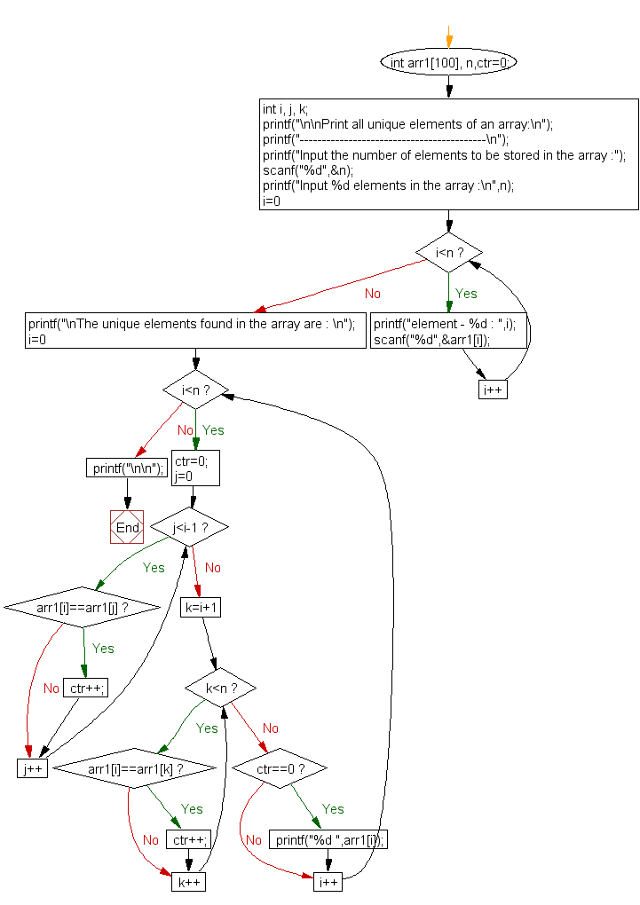

**ALGORITHM:**

1. For every index i from 0 to len_array(n) – k, i.e *n – k*, traverse the array from *i* to *i + k*. This is the window
2. Traverse the window, from *i* to that index and check if the element is present or not.
3. If the element is not present in the prefix of the array, i.e no duplicate element is present from *i* to *index-1*, then increase the count.
4. Print the count.